2651. Calculate Delayed Arrival Time

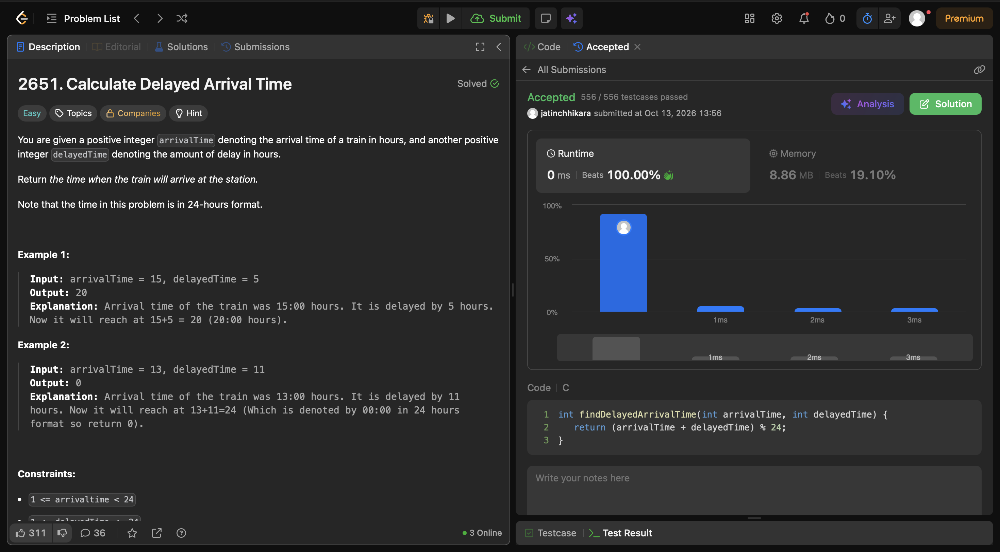
Code:
int findDelayedArrivalTime(int arrivalTime, int delayedTime) {
return (arrivalTime + delayedTime) % 24;
}

